****NORTH CLACKAMAS SCHOOL DISTRICT

**Community Agency Partnership Handbook**



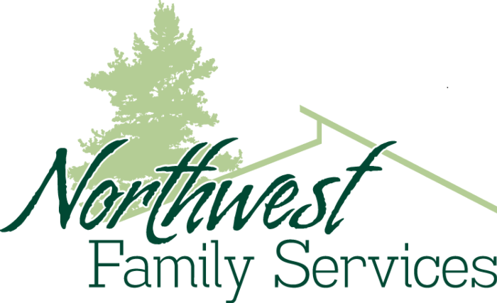







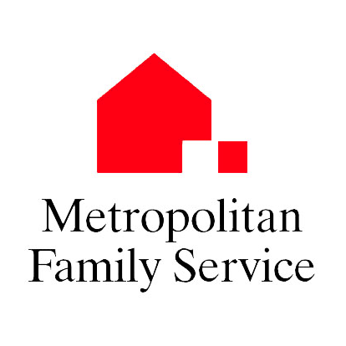











**Building a Partnership Between**

**North Clackamas School District and a Community Health Organization**

**Introduction –**

**Plant Seeds**

* You never know what opportunity will grow.
* Process may take 3 times longer than expected.
* Attend County Resource meetings
* Line up your champions.
* As momentum builds, opportunities appear.

**What Schools need to know about Agencies**

* They may not get how schools work.
* They will need an on-site Champion.
* We may need to restructure our systems to support them (call slip, etc.).
* Agencies may need to have billable visits.
* Might need an MOU.

**What Agencies need to know about Schools**

* We are skeptical of people who want to “help” us.
* We may not understand the world of non-profits.
* We may not understand how to met your needs.
* We run on a School Calendar.
* We may have a bell schedule like a Block Schedule.
* We might not understand HIPPA/FERPA.

**Find your common ground**

We both want students to…

* be mentally healthy.
* not be hungry.
* feel safe at school.
* ready for college.
* be prepared for a career.
* achieve at a high level.

**Step 1 – Discussing the Potential for a Partnership**

1. **Phone call making initial contact**
2. **Initial meeting set up with a representative of the agency and North Clackamas School District**
   1. Describe NCSD’s mental health and wellness program goals
   2. Describe the population the school serves
   3. Discuss overall compatibility between the school’s needs and services the agency provides
3. **Set date for agency representative to come to the school**
   1. Invite Director of Social Services, Principal and school counselor(s) to meet agency representative
   2. Compatibility
      1. Is organization a “good fit” for school and population targeted for services?
      2. Is the agency individual a “good fit” re: work style, building rapport with kids, communication style, etc.?
      3. Any potential difficulties or challenges to the partnership?
         1. Is there office space available?
         2. Can the school commit office support (copier, printer, phone)
         3. Parent concerns?
         4. MOU needed?
         5. Time constraints?
         6. District approval needed
         7. PR issues?
         8. Other?
4. **Tour of school site**
   1. Introduce agency representative to administrator, counselor(s), secretary
   2. Help agency representative develop sense of school atmosphere, population
   3. Show work space where agency representative will facilitate groups, work one-on-one, or provide other health services
5. **Make a decision whether this is an appropriate partnership**
6. **Set date for a Start-up meeting including school personnel and organization contacts**

**Step 2 –Setting Up Partner Services**

1. **Partner Agency Information** 
   1. Obtain contact information of partner agency and supervisor
   2. Meet with partner organization supervisor
   3. Memorandum of Understanding signed by agency and district officials
   4. Who carries the liability?
   5. Identify Targets, Goals, and Objectives
   6. Set up standing meeting times for agency facilitator and school staff for check-ins
2. **Support the Partnership Well**
   1. Give them an office, phone, copy code, district email address, district partner ID badge.
   2. Figure out how the current systems can support the objectives they need to meet.
   3. Support them accessing students-using call slips, secretaries, etc.
3. **Process and Timeline to Begin Services**
   1. Decide who is the school contact; counselor or administrator
      1. Provide phone, email info
      2. Set a meeting to explain referral process to all involved
      3. Explanation of FERPA and HIPAA and how to work with both
4. **Communication-**
   1. Process and Timeline to Begin Services
   2. Decide who is the school contact
   3. Communication to staff, students, & parents
   4. Routine communication between agency representatives, counselors, and administration
   5. Send a communication about the opportunity and process to staff, students, & parents
5. **Technology**
   1. Check if partner agency computer can access agency system
   2. Does the individual need an NCSD Gmail account?
   3. Add individual’s agency email address to the school staff email group list
   4. Connect individual’s computer to the local printer/copy machine
6. **Referral Process** 
   1. Counselors develop referral list of students in need of services
   2. Any staff member can refer to the counselor
   3. All students are referred to the school counselor before they are referred to agency
      1. It provides the opportunity for the counselor to communicate with the parents
      2. It avoids triangulation with the school, family, and agency
      3. It avoids FERPA/HIPAA conflicts by getting consent to share information signed
   4. Counselor meets with a student to describe the agency and services, assess needs, interest level, compatibility, etc.
   5. If student is interested, counselors has Parent Conversation gets Consent for a referral to agency
   6. Referral/Consent form completed and handed over to agency
      1. release of information form between counselor and agency person is signed
7. **Agency person interviews student**
   1. Agency partner meets with referred students, introduces self, describes services, assesses each student’s needs, interest level, etc.
   2. Students receive parent consent form with description of services and time frame of participation
   3. Agency partner begins services
   4. Routine communication between agency representatives, counselors, and administration
   5. Figure out how services and the student benefits will be assessed
   6. Agency partner is not given student schedules. Requests for students go to designated secretary to send a call slip to student in class.
   7. Student academics is always the priority. Appointments to agency are secondary.
8. **Support Group Details to decide**
   1. Curriculum or focus of the group? Closed or Open group? Gender?
   2. How many? 8-12 is recommended
   3. Time of group (During or after school? Which period/day?)
9. **Logistics**
   1. Outline timeframe for services at school (Start/End dates)
   2. Establish communication protocol, including parent consent form
   3. Partner signs in/out and gets/returns key at main office
   4. Partner has students sign in on paper at each group session and returns to attendance office
10. **Attachments that should be included in this packet**
    1. Referral Form
    2. Consent Form
    3. Release of Information Form
    4. School Calendar w/ school holidays, non student days
    5. School map
    6. Bell schedule
    7. Office / Staff / Room phone extensions list
    8. List of school staff email addresses
    9. Master Class Schedule
    10. Outside Resource phone numbers
    11. Fire Drill/Lock down procedures
    12. Mandatory Reporting Protocol form
    13. List of supervisory names and contact

**Step 3 - Sustaining Services and Long Term Planning**

1. **Training**
   1. Mandatory reporting review
      1. To DHS, parents, counselor, administrator
      2. Suicide, abuse, threat of harm
   2. Crisis Response
      1. Notifying administration
2. **Checking In**
   1. Meet with school personnel regularly (monthly ?) to review, debrief, discuss new issues
   2. Set up a quarterly/half-yearly meeting with partner agency supervisor to review successes or issues
   3. Consult with school counselors weekly
   4. Address sustainability of partnership
   5. If there are several partners in a school
      1. Set up a weekly partner consultation meeting including a counselor
3. **Collecting Data**
   1. Set up a monthly Status Report to be emailed to NUHS and supervisor
      1. How many students were served?
      2. How many sessions occurred?
   2. Anecdotal research
   3. Pre/post student self-report questionnaire
4. **Debrief the experience**
   1. What worked well?
   2. What was missing?
   3. What needs to be revised?
   4. What would the facilitators change?
   5. What would school staff change?
5. **Seeking Additional Funds**
   1. Sharing the school’s Student Data with partner agency
   2. Discuss how our joint efforts can be used to apply for grants or other funding
6. **Discuss continued partnership** 
   1. Set up a tentative meeting next school year
   2. Discuss if there is room for growth**Attachments that should be included in this packet:**
   * Referral Form
   * Consent Form
   * Release of Information Form
   * Safety Plan Form
   * School Calendar with holidays, no student days
   * School map
   * Bell schedule
   * Class Schedule
   * List of School Staff Email Addresses
   * Office / Staff / Room phone extensions
   * Master Class Schedule including lunches
   * Outside Resource phone numbers
   * Fire Drill/Lock down procedures
   * Contact Phone Number list
   * Mandatory Reporting Protocol form
   * List of supervisory names and contact info
   * _________________________________
   * _________________________________