TOOL- STAKEHOLDER MAP

Teams should identify which individuals or organizations are most important to engage to impact your vision and how best to engage them. The Stakeholder Map helps you prioritize stakeholders by assessing their level of interest and influence related to implementing or sustaining your school-wide wellness efforts. Brainstorm and plot stakeholders in the area that best represents their interest and influence. The Stakeholder Map shows how best to engage stakeholders depending on where they are on the map.

How to Use the Tool:
- On the stakeholder map, the x-axis () shows the level of interest that a stakeholder has in implementing or sustaining your school-wide wellness efforts. The closer to the left on the x axis, the less interest the stakeholder has and the further right, the more interest. The y-axis () shows the level of influence they have in implementing or sustaining your school-wide wellness efforts. The closer to the bottom on the y axis, the less influence the stakeholder has and the further up, the more influence.
- Teams can plot 5-10 stakeholders on the map in the quadrant that best represents their interest and influence. We suggest plotting at least 5, but no more than 10, to the map or else the map gets too crowded. As you plot the stakeholder, the more interest the stakeholder has in school-wide wellness, the further to the right on the map. The more influence, the higher up on the map. For example, a very influential stakeholder with little interest in implementing or sustaining school-wide wellness will be at the top left hand corner.
- The following questions may help teams fill out the map:
  - To help assess stakeholders’ interest, the team can ask themselves “how does school-wide wellness align with the organization’s/person’s thinking and/or current work?”
  - To help assess stakeholders’ influence, the team can ask themselves “what power does this organization/person have to impact our vision?” Keep in mind that power can be used to positively or negatively to impact your vision.
- The Stakeholder Map also identifies how best to engage stakeholders depending on where they are on the map (see example below). For example, low influence/low interest (bottom left corner) stakeholders only need occasional contact in case their influence or interest changes. High influence/high interest (upper right corner) stakeholders are most impacted by school-wide wellness efforts and are empowered to do something about it; they should be engaged.
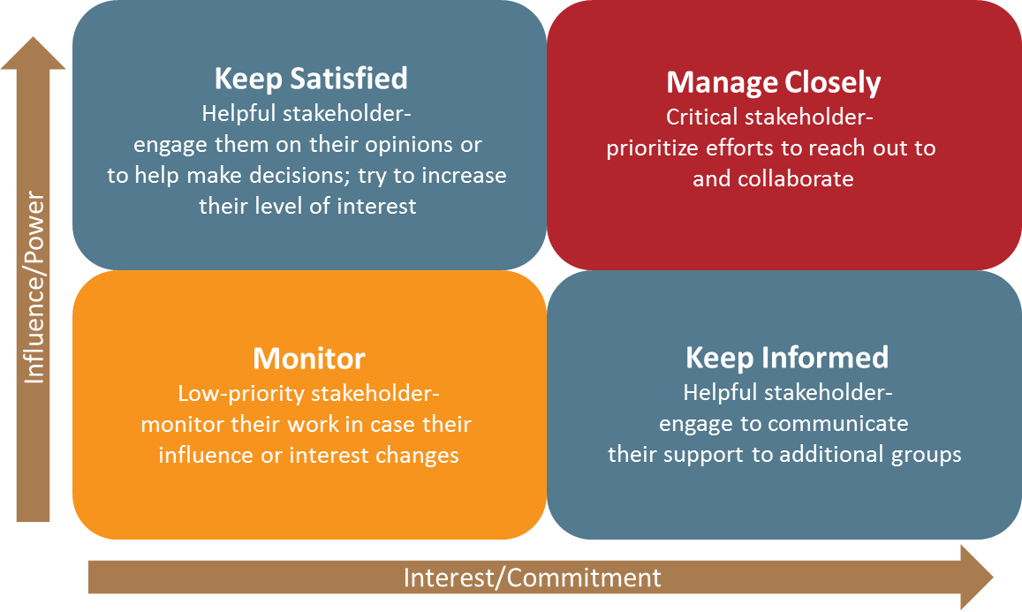

Stakeholder Map (to fill in)
Print this page and write at least two stakeholders in the red box and one to two in each blue box. As you determine where to place each stakeholder, think about the following questions: What do you think the prime interests of this stakeholder are? What are they able to influence?

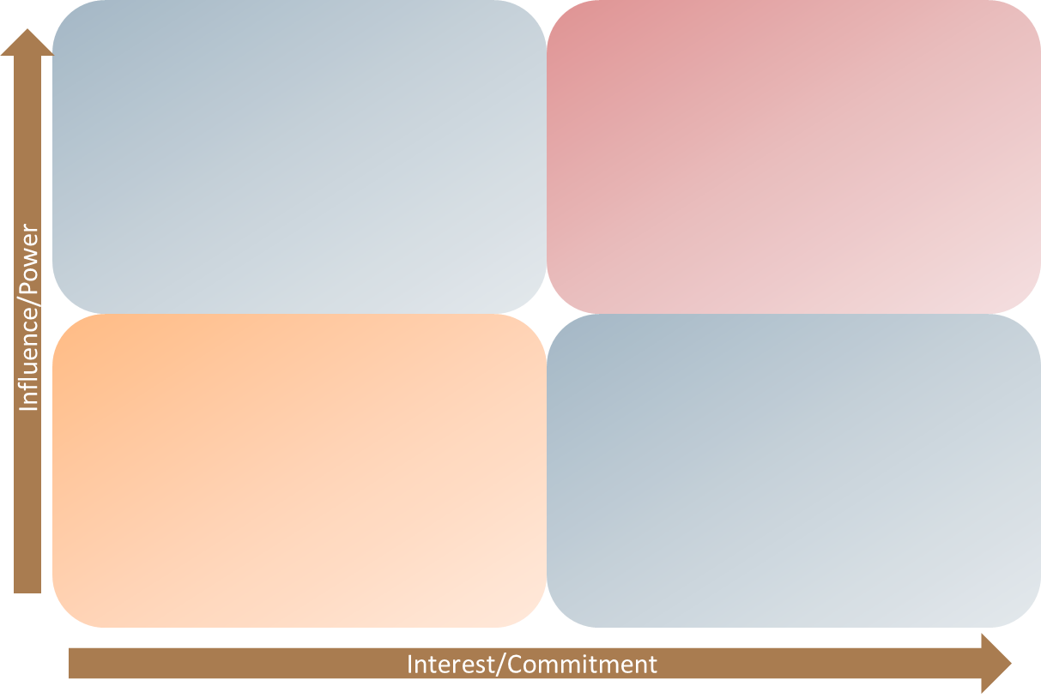

Modified from: Perritt, S. (5 November 2015). Projects Gone Wild – Why Do Projects Fail? Stakeholder Engagement. Celedon Partners. Retrieved from http://celedonpartners.com/blog/projects-gone-wild-why-do-projects-fail-stakeholder-engagement/

