FIGHTING VACCINE FATIGUE
Parents and guardians of pediatric patients may feel overwhelmed by trying to keep abreast of new information and following modified well-visit schedules to get their children caught up on vaccines. They may also be vulnerable to fear-based misinformation and may display some vaccine hesitancy. Health providers can talk to parents and guardians regarding the need for routine shots and provide realistic timelines for patients to complete them.

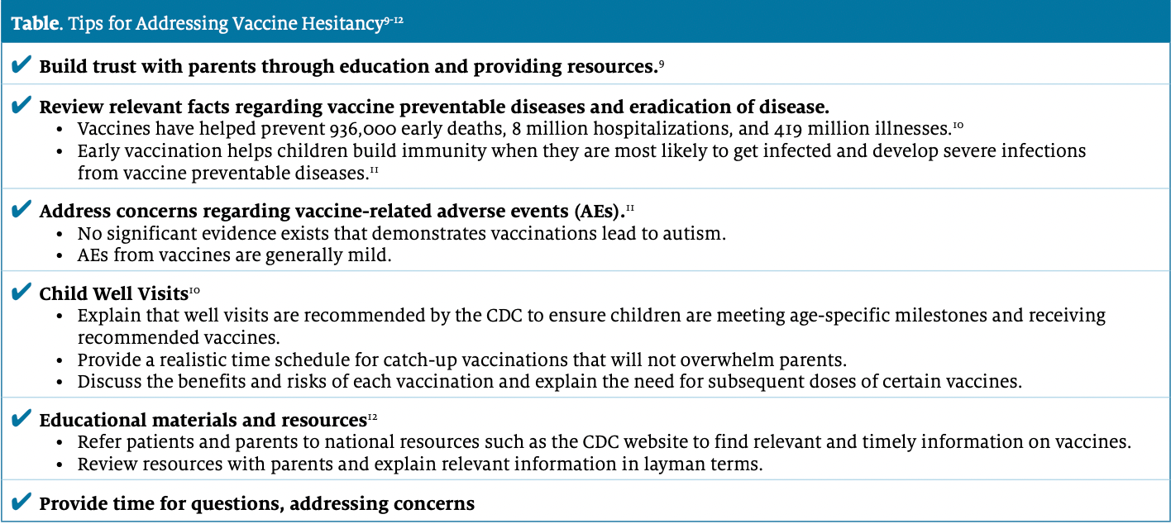
Immunization has been the major factor in the eradication of diseases such as measles, mumps, and rubella; the reduction of rates of influenza; and most recently, the mitigation of the spread of COVID-19. Stay-at-home orders assisted in this effort, but also contributed to a significant decline in pediatric well visits during which routine vaccinations are given. With the reopening of school systems, it is important that providers educate parents regarding the need for COVID-19 and other catch-up vaccinations to ensure their children are protected. ACIP provides detailed vaccine schedules for pediatric patients, including catch-up timelines.
Providers should begin disseminating these messages early to ensure children are immunized on schedule, and they need to allocate sufficient time for in-person visits during which issues such as vaccine hesitancy, vaccine fatigue, and other obstacles can be addressed. In this way, we can close the gap in vaccination rates for our most susceptible populations.

