STAFF INSTRUCTIONS
________________________________________________________________________________________________________________________________________________

Office Staff: This box contains the items below. Instructions for immediate
distribution follow on the back.
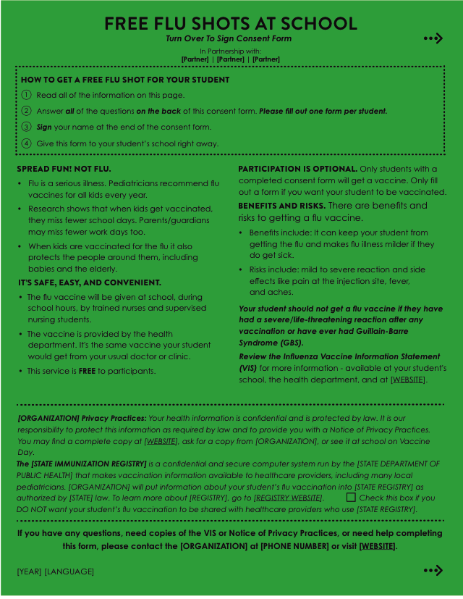
- CONSENT FORMS
in multiple languages
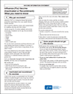
(1 per student)
_______________________________________________________________________________________________________________________________________

- VACCINE INFORMATION STATEMENTS (VIS)
in multiple languages
_______________________________________________________________________________________________________________________________________
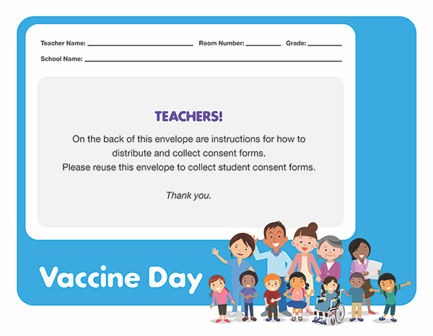

- TEACHER ENVELOPES
to collect student consent forms
(1 per teacher)
_______________________________________________________________________________________________________________________________________
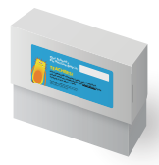

- COLLECTION BOX
to collect teacher envelopes

_______________________________________________________________________________________________________________________________________

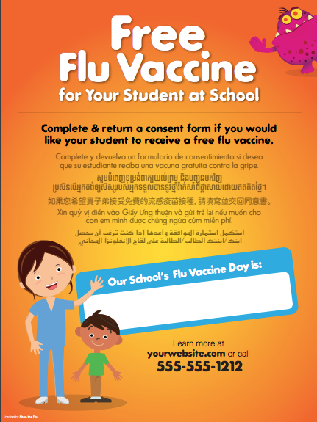
- POSTERS
to advertise the date of the program

TURN OVER FOR INSTRUCTIONS

Please follow these instructions for immediate distribution of materials in this box.
STEP 1: Divide and Distribute Consent Forms and Teacher Envelope
- Divide consent forms (1 per student) by class.
- Multiple languages are provided. [LANGUAGES] are bilingual – they have an English copy stapled to them.
- Include ONE Teacher Envelope per class.

STEP 2: Set Up Consent Form Collection Box
- Write in the date of your Vaccine Day in the space provided
on the box and place in a visible place in the front office.
- Teachers will return student consent forms using the provided
teacher envelopes and store them in this box.

STEP 3: Put Up Posters Around Campus
- Write in the date of your Vaccine Day in the space provided.
- We recommend putting one poster up in the front office.
Place the 2nd poster anywhere you’d like.

STEP 4: Keep Vaccine Information Statements in Front Office
- An included folder contains one copy of the Influenza Vaccine Information Statement (VIS) in [#] languages: [LIST LANGUAGES]
- Make photocopies for parents/guardians if they request one (please keep the originals).

Thank you for your support!

Please have all signed consent forms returned 3 days before your school’s Vaccine Day.
_____________________________________________________________________________________________________________________________________________
Any questions or concerns can be addressed to: [CONTACT]
[CONTACT EMAIL ADDRESS]
[CONTACT PHONE NUMBER]

