TEACHER INSTRUCTIONS

[PROGRAM NAME]

Teachers: Follow the instructions below for immediate distribution of materials.

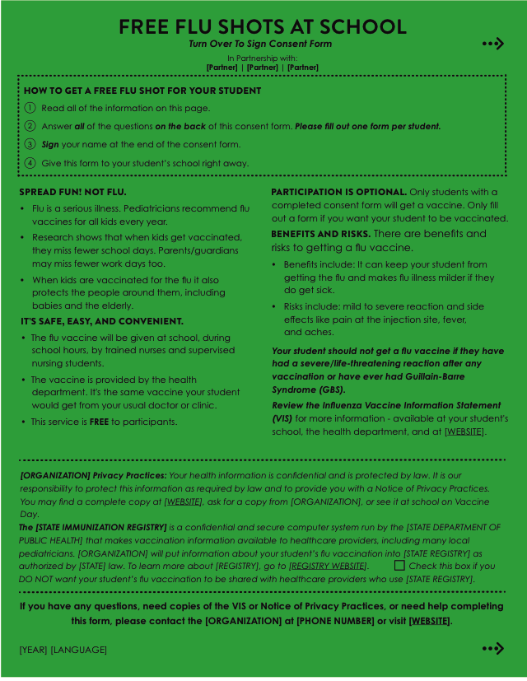
STEP 1:
DISTRIBUTE CONSENT FORMS
TO YOUR STUDENTS
(1 per student)

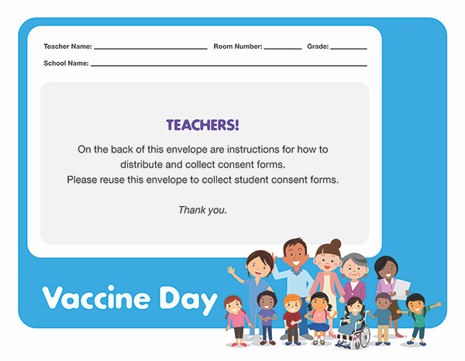
STEP 2:
COLLECT COMPLETED

CONSENT FORMS
in this envelope.

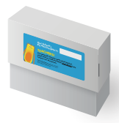
STEP 3:
BRING THE ENVELOPE FULL
OF STUDENT CONSENT FORMS

TO THE FRONT OFFICE and store in
the collection box 3 days
before your school’s Vaccine Day.

TURN OVER FOR MORE INSTRUCTIONS

Please read below for more detailed instructions.

General Information
- [PROGRAM NAME] is coming to your school to give free flu vaccine to students [AND STAFF] Please check in with the front office for your school’s Vaccine Day date.
- Participation is optional and getting a flu vaccine is not a requirement to attend school.
Only students with a completed consent form will get a vaccine.
- For more information, including lesson plans and coloring pages, visit [WEBSITE] or call [PHONE NUMBER].

Preparing for the Vaccine Day
- Once the consent forms are distributed, students should return their completed and signed consent form as soon as possible.
- Please bring your envelope full of consent forms to the main office 3 days before your school’s scheduled Vaccine Day. In the main office there is a collection box to store the forms.
We will accept forms up until the Vaccine Day but prefer forms earlier so we can check for errors.
- We have consent forms in [#] languages, if you need different languages than what you
were provided please ask the front office for extras. Families can also download a copy
at [WEBSITE].

On the Vaccine Day
- We want to respect class time as much as possible. On the Vaccine Day, staff will come
to your class and bring participating students to the area where the [VACCINATORS] set up.
- When we come to your classroom to collect students you will be asked to help identify participating students in your class. This should take less than 2 minutes. We thank you
in advance for your support in ensuring student safety.
- [ALL SCHOOL STAFF CAN ALSO GET A FREE FLU VACCINE. IF YOU WANT A VACCINE, YOU CAN FILL OUT AN ADULT CONSENT FORM ON YOUR SCHOOL’S SCHEDULED VACCINE DAY.]
THANK YOU FOR YOUR SUPPORT!

Any questions or concerns can be addressed to:
[CONTACT NAME/ORGANIZATION]
[CONTACT EMAIL]
[CONTACT PHONE NUMBER]

